Assignment 4 –BED

Problem Statement:

You are required to create a Employee Management Rest Api based Web application, where you will be developing CRUD(Create,Read,Update and Delete) functionality along with Sorting and some concepts of security

**Requirement 3:** Now Your application should be able to add employees data in the db if and only if the authenticated user is **ADMIN**-

User rohan has no admin rights after logging in as user rohan, add employee is forbidden for admin it’s allowed.

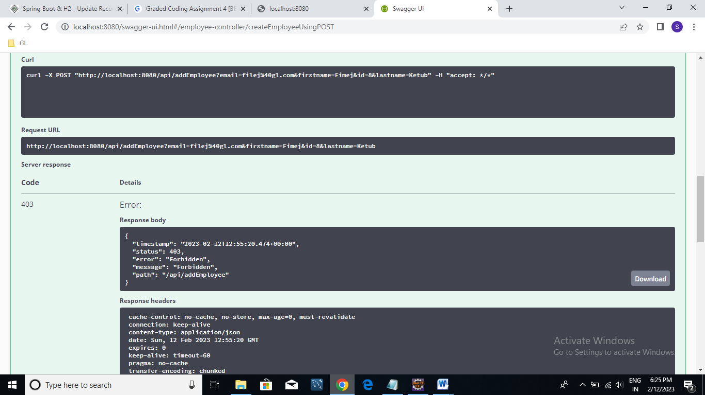

User Samarth has admin rights Samarth is able to add employee.

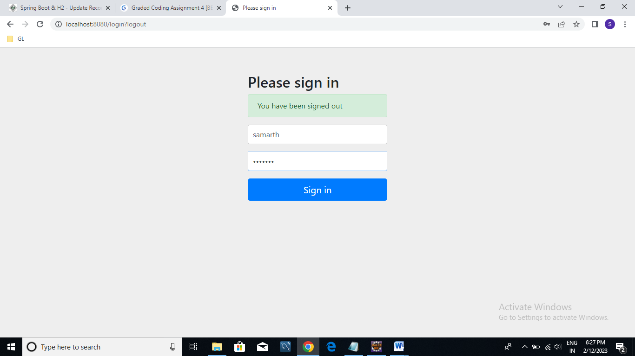

New employee is added successfully when logged in user has admin rights.

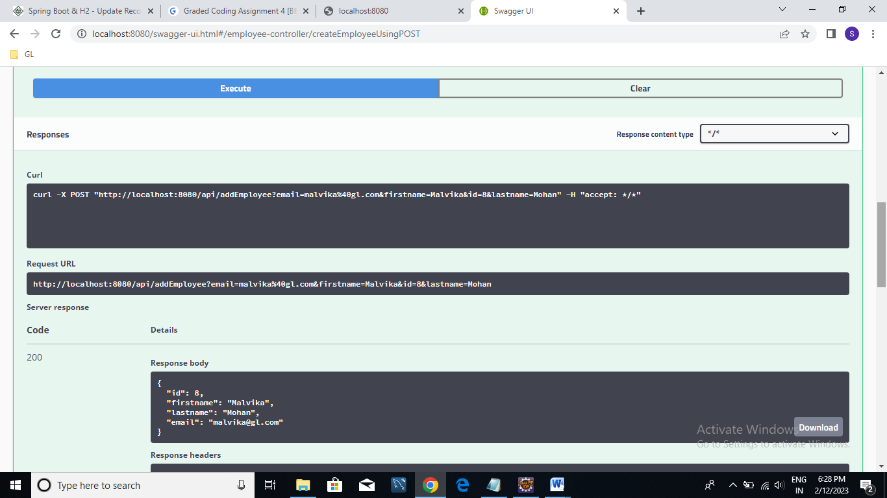

Result JSON :



**Requirement 4:** Your application should provide an endpoint to list all the employees stored in the database.

All the employees present in database are listed successfully.

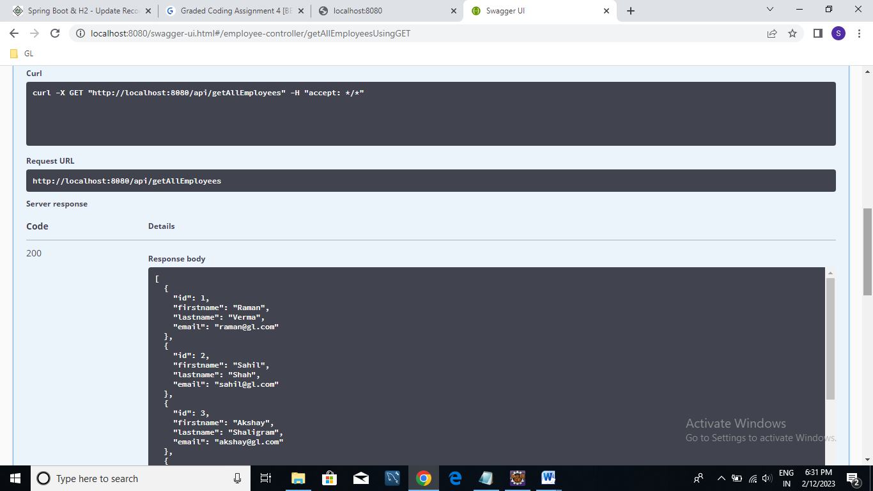

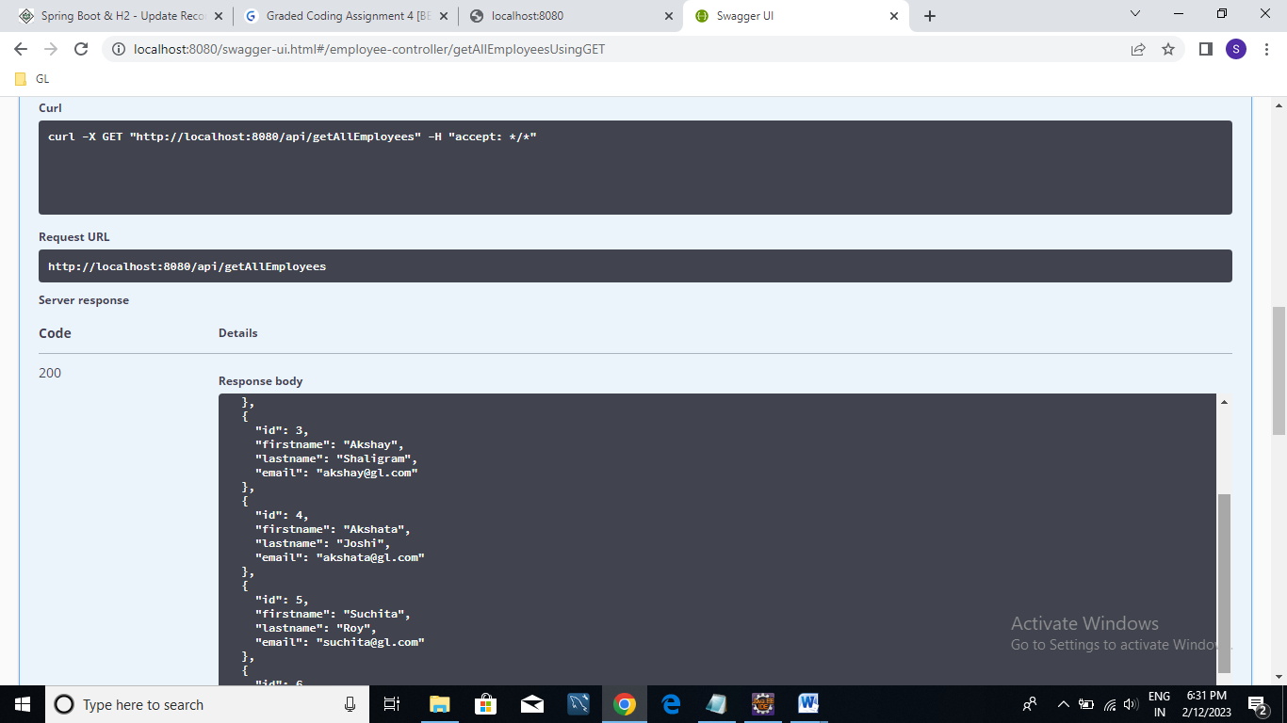

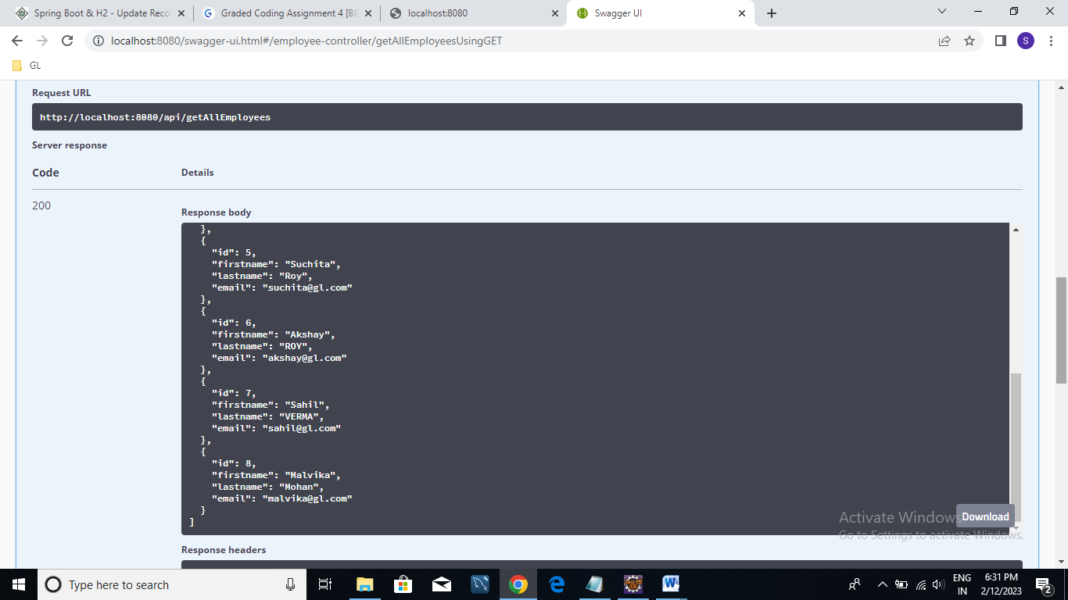

Result JSON:



**Requirement 5:** Your application should provide endpoint to fetch or get an employee record specifically based on the id of that employee.

Get employee details of id 3:

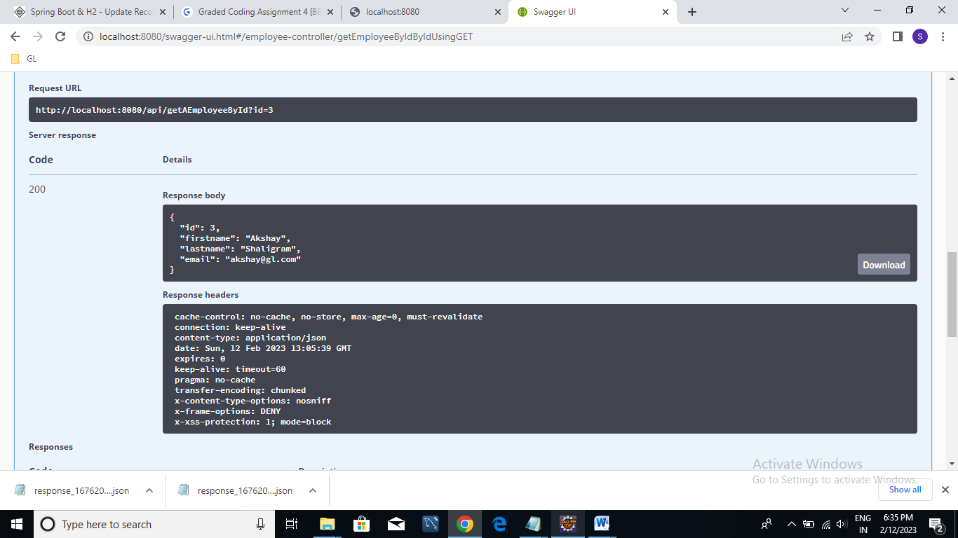

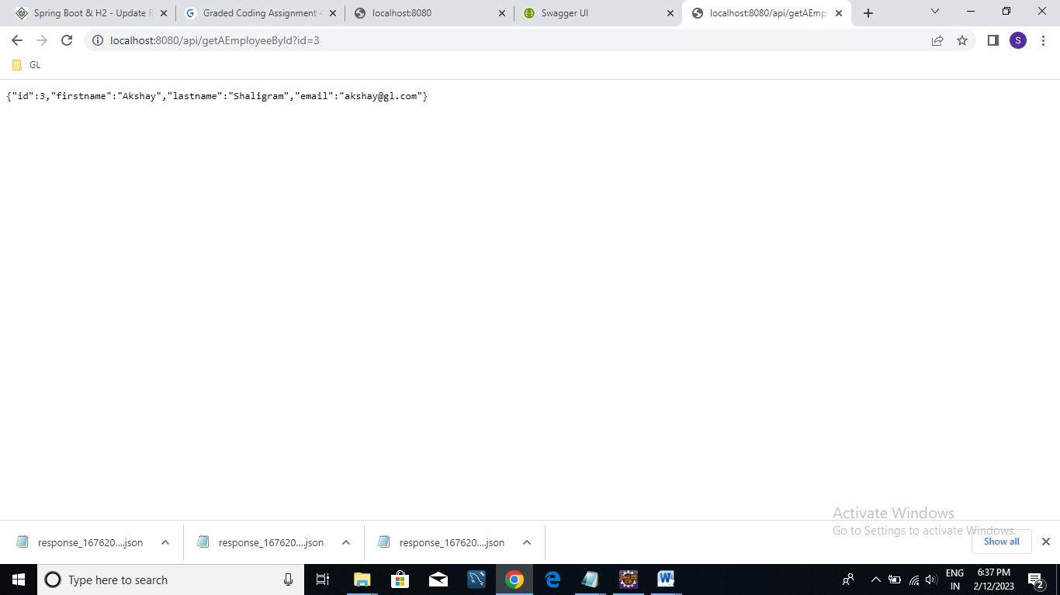

Result JSON:



**Requirement 6:** Your application should provide an endpoint to update an existing employee record with the given updated json object.

Id 4 is updated

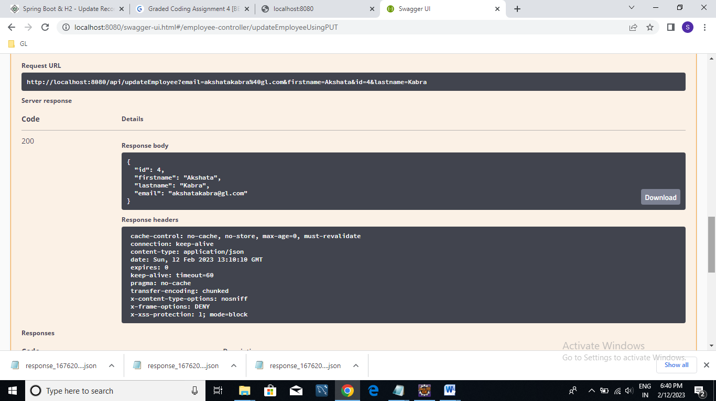

Result Json:



**Requirement 7:** Your application should also provide an endpoint to delete an existing employee record based on the id of the employee.

Deleted employee with id 4.

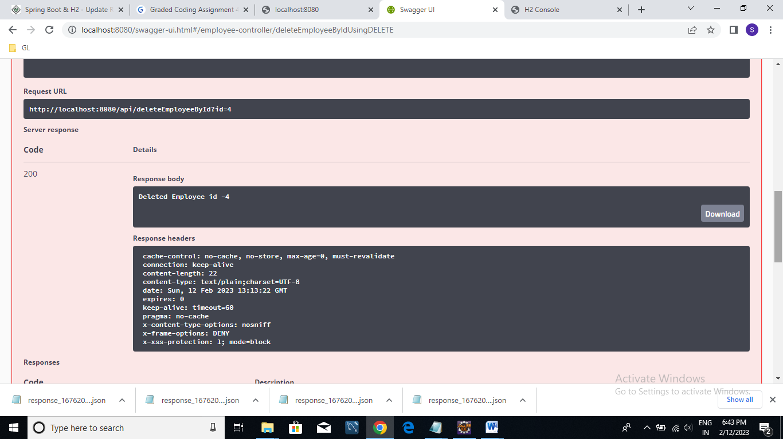

Result:



**Requirement 8:** Your application should provide an endpoint to fetch an employee by his/her first name and if found more than one record then list them all.

Searched with Fname Akshay. Listed 2 employees exist in db with name Akshay

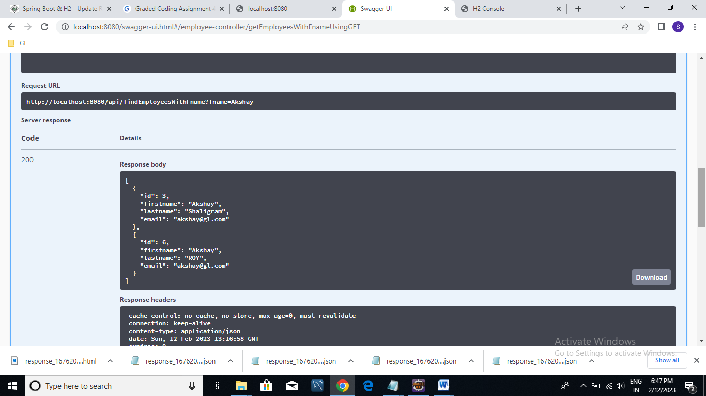

Result JSON:



URL:

**http://localhost:8080/api/findEmployeesWithFname?fname=Akshay**

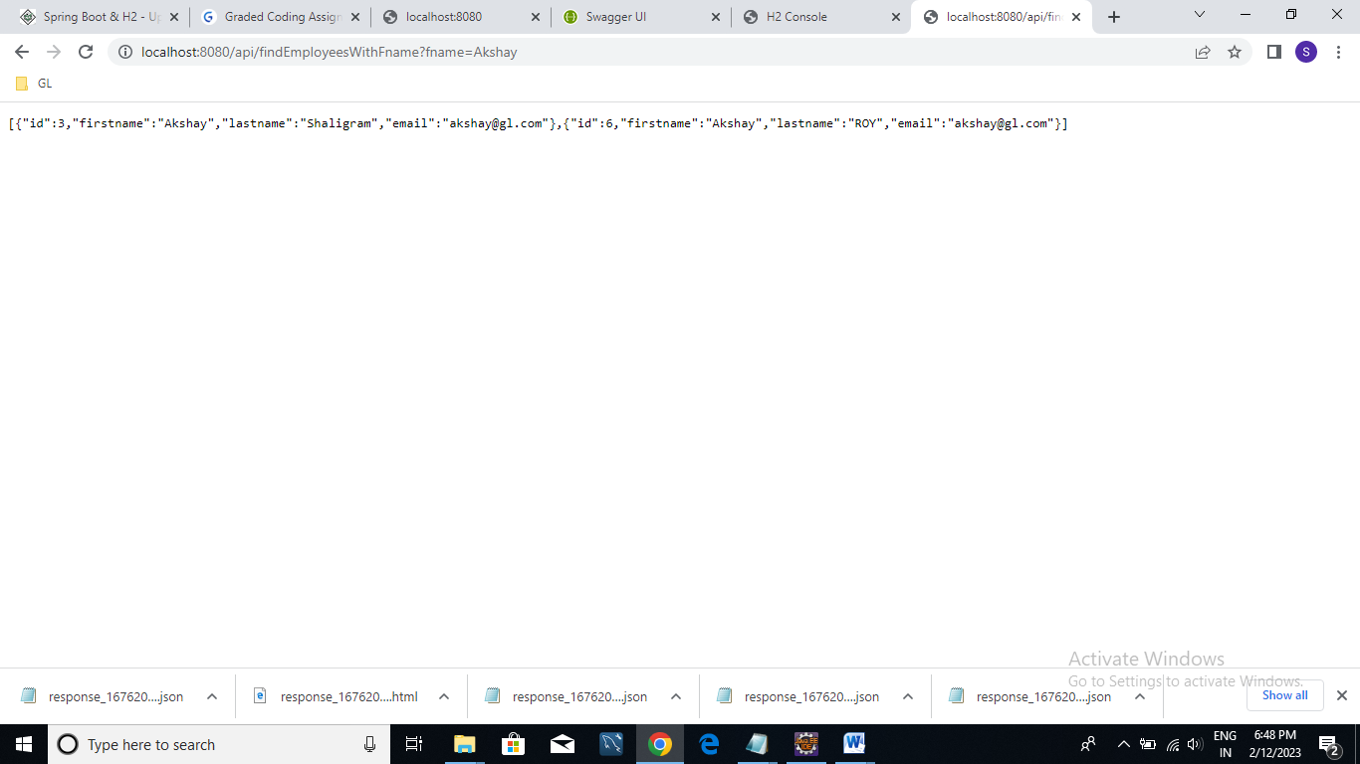

**Requirement 9:** Your application should be able to list all employee records sorted on their first name in either ascending order or descending order .

Sorted in ascending order of first name:

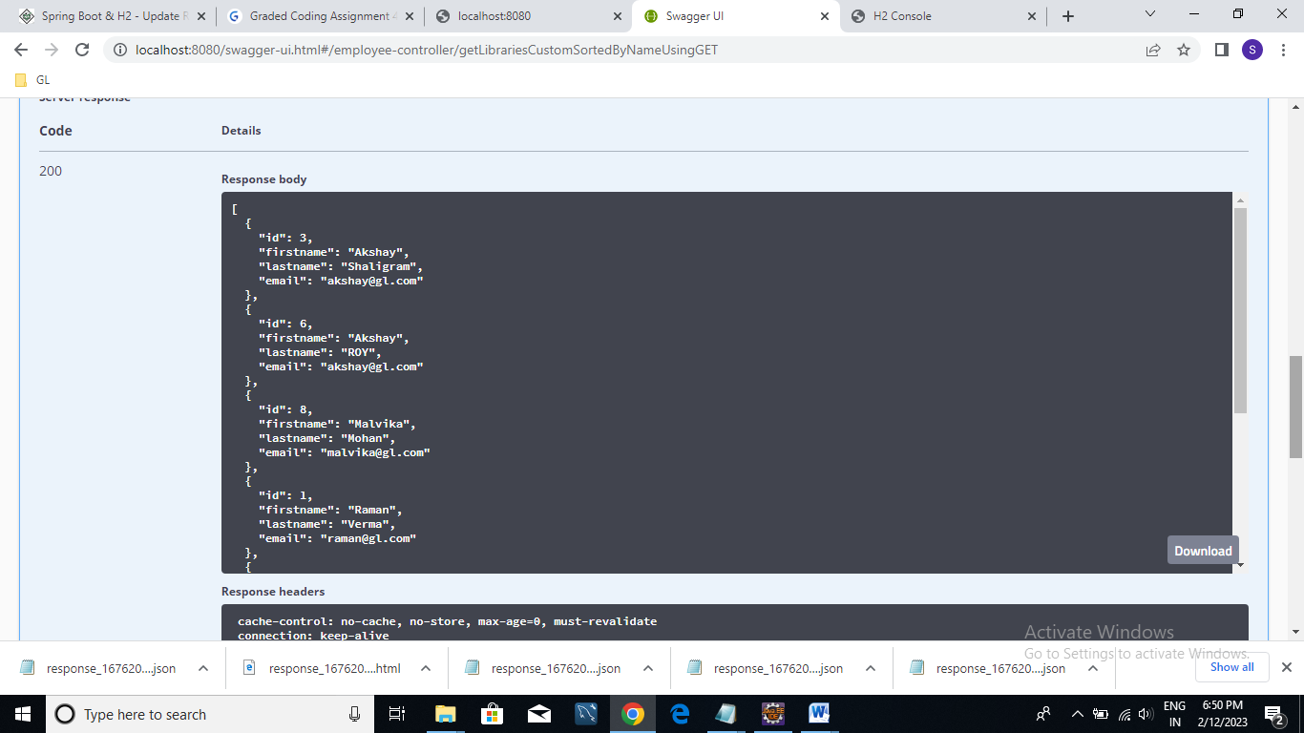

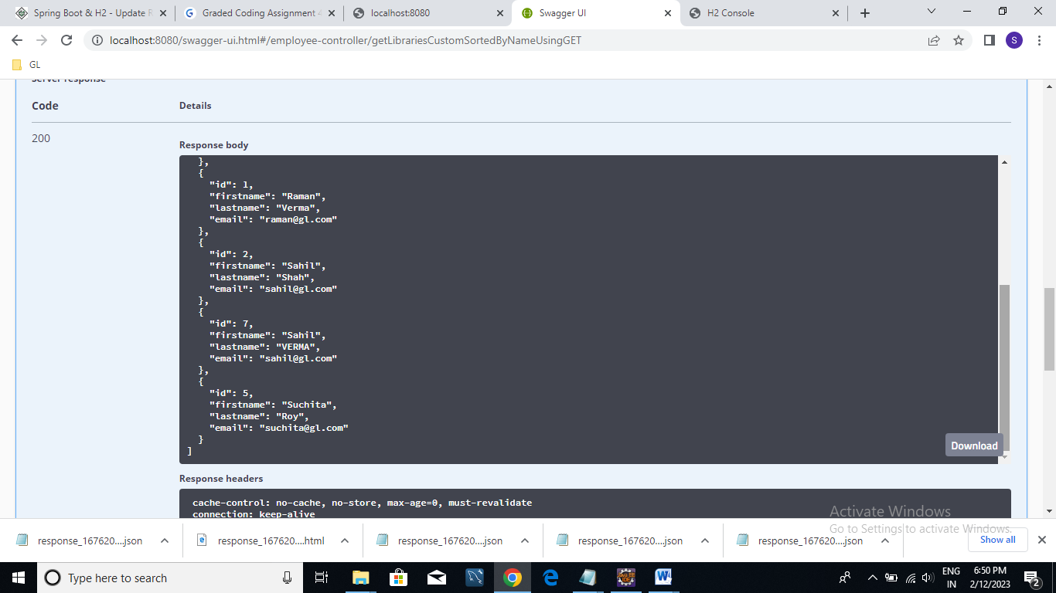

JSON result:



URL:

http://localhost:8080/api/getEmployeesCustomSortedByFname?direction=ASC

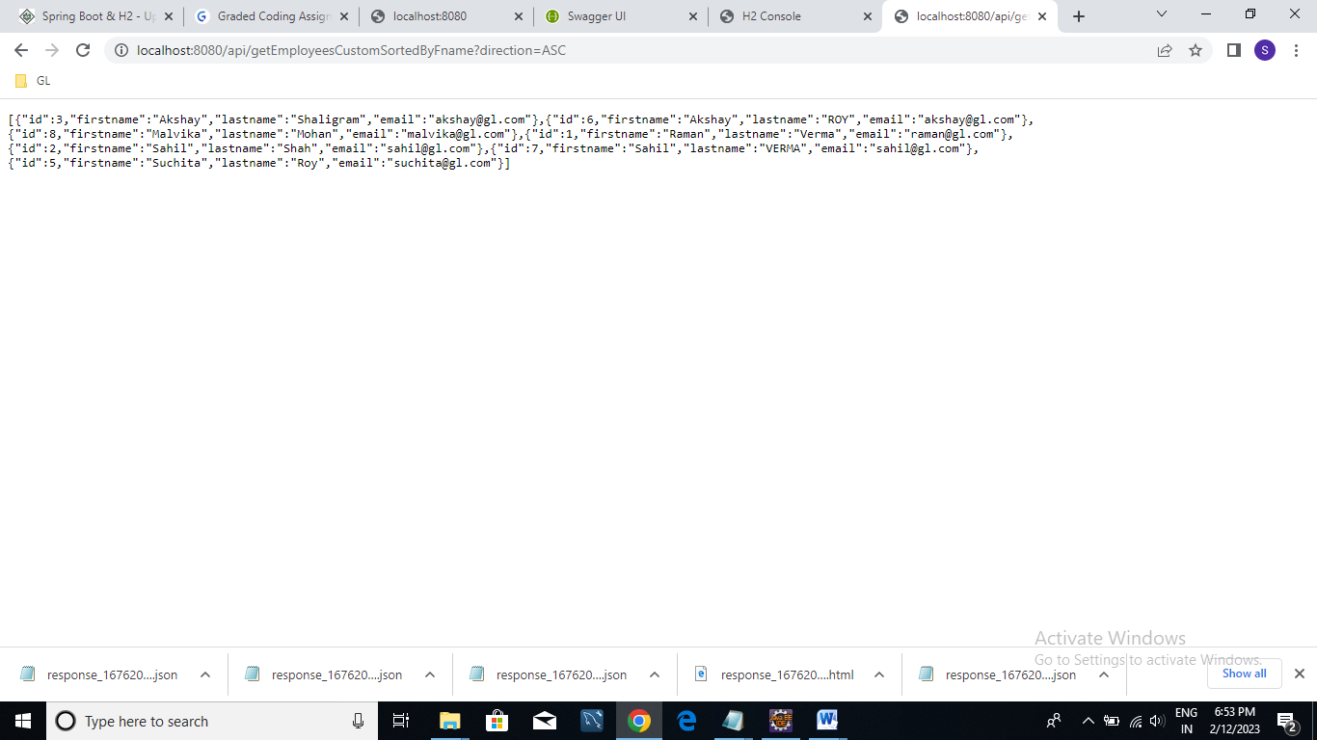

Sorted in descending order of first name:

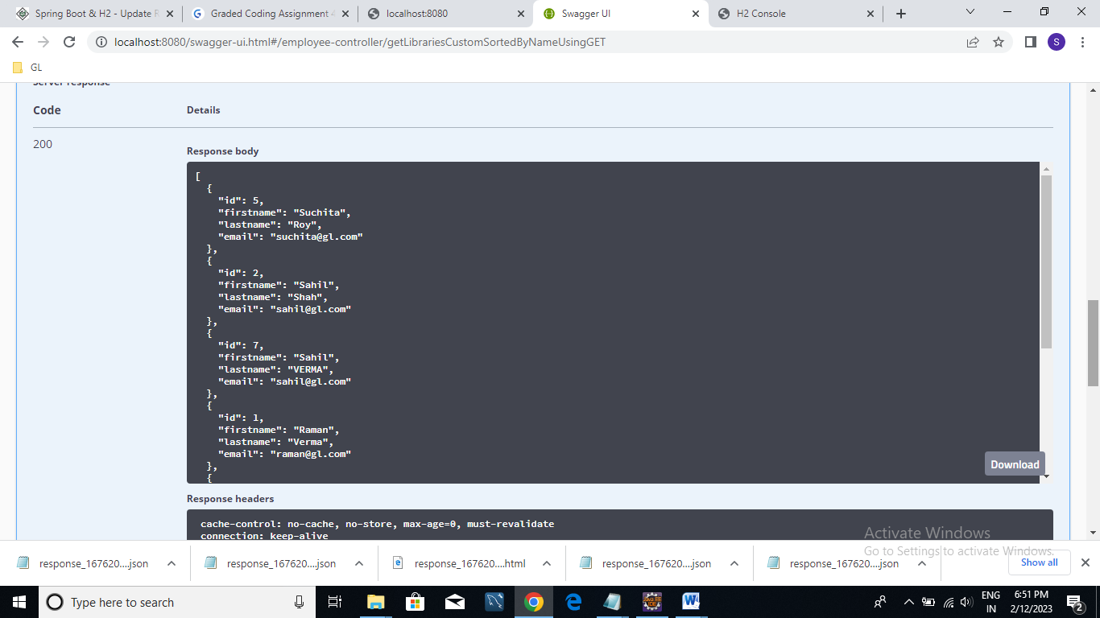

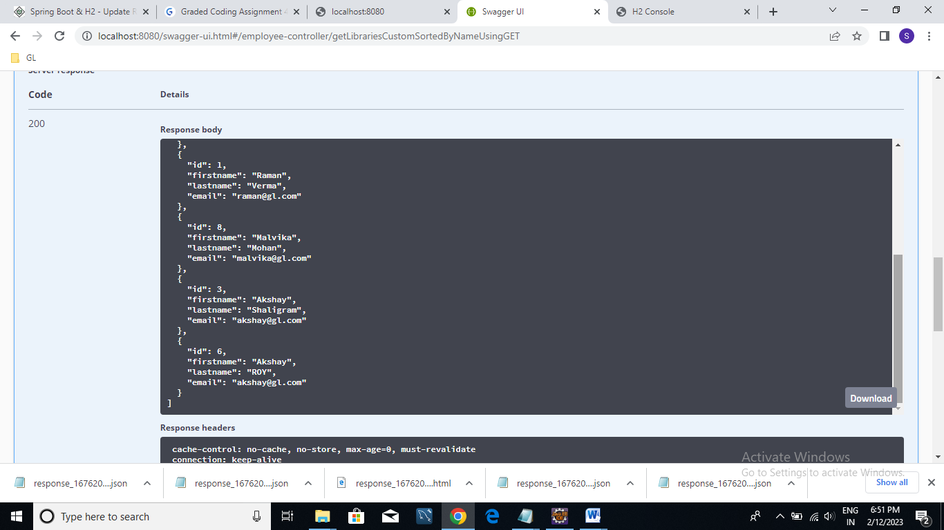

Json Result:



URL:

**http://localhost:8080/api/getEmployeesCustomSortedByFname?direction=DESC**

